Personal Profile
LLM. MBA Eng. Christian Thomas

Executive Summary
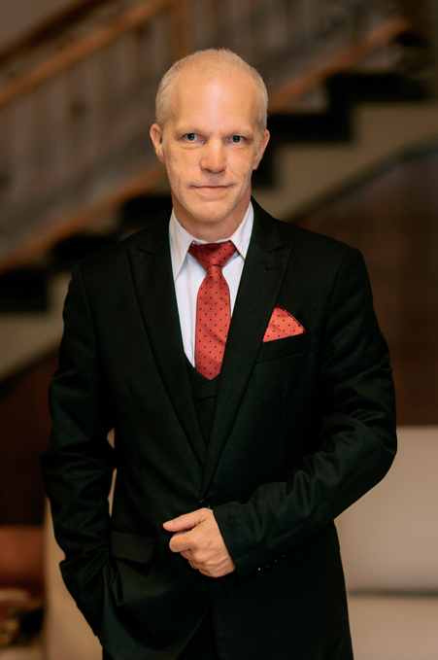
Christian Thomas is a highly accomplished global executive, legal and financial strategist, and visionary entrepreneur whose distinguished career spans more than three decades and multiple industries. With an exceptional academic foundation uniting Law, Economics, and Engineering, he combines technical mastery, financial expertise, and legal precision to drive sustainable growth and governance excellence across international markets.

As Group Executive Chairman of Iustus Mercatura Inc., a multidisciplinary holding company active in global commodity trade, agricultural products, and finance, and President of FITC Energy Group Inc., specializing in international petroleum trade, Mr. Thomas defines and implements corporate strategy, compliance frameworks, and innovation programs. His leadership style is guided by integrity, discipline, and a value-driven philosophy that emphasizes transparency, responsibility, and long-term sustainability.

Academic and Professional Foundation
Mr. Thomas holds a Master of Laws (LL.M.), a Bachelor in Economics, and dual degrees in Civil Engineering and Electrical Engineering from highly ranked German universities known for academic rigor. He also completed a Master’s in Paramedic Studies, undertaken in his early years out of a deep commitment to medicine and humanitarian service.
At just sixteen, he began serving as a Paramedic with the German Red Cross, a vocation he continued into his late thirties. Although professional and personal demands eventually limited his active participation, his compassion for people and dedication to medical service have remained lifelong motivations. This humanitarian ethos continues to inform his executive and advisory work.
Currently, Mr. Thomas is pursuing a second MBA in Finance and Risk Management at Abertay University (UK). Upon completion, he intends to continue toward a Doctorate in the same field, further strengthening his expertise in financial systems, global risk, and compliance.

Career and Leadership
Christian Thomas began his entrepreneurial journey at 18 years old, founding his first company in the construction industry. Demonstrating exceptional foresight and determination, he later established a renowned enterprise in the Finance and Insurance sector in Germany, all while serving in the German Military—an experience that forged his leadership discipline, strategic focus, and resilience.
Over the ensuing decades, he has held executive and board-level positions within multinational firms spanning construction, medical supply, international trade, and energy. He is recognized for guiding organizations through market expansion, structural reform, and complex regulatory transitions. His leadership hallmark is a strategic yet ethical approach, balancing profitability with governance excellence and stakeholder trust.
Today, as head of Iustus Mercatura Inc. and FITC Energy Group Inc., Mr. Thomas drives corporate transformation through digital compliance technologies, ethical investment frameworks, and sustainable development models that reinforce the companies’ global standing.

Philosophy and Humanitarian Engagement
At the heart of Mr. Thomas’s leadership philosophy lies the conviction that ethical governance and social responsibility are inseparable from corporate success. Beyond his corporate endeavors, his humanitarian commitments have taken him to Africa, where he has advised governmental and nonprofit organizations on legal and financial matters, promoting transparency, accountability, and sustainable economic empowerment.
His business and humanitarian activities share a common purpose: to improve lives through knowledge, structure, and opportunity. By cultivating cultures of ethics and empathy within the organizations he leads, he ensures that commercial achievement never comes at the expense of human welfare.

Recent and Distinguished Achievements
- 2025 – Invitation to the Forbes Leadership Council (currently under review), recognizing his influence as a global executive and innovator.
- Two invitations to serve as a United Nations Ambassador for national Development, in Kenya and Uganda acknowledging his reputation for principled leadership and advocacy for sustainable growth (respectfully declined for personal reasons).
These distinctions reflect his international credibility and enduring commitment to responsible progress in both business and society.

Vision and Outlook
Christian Thomas continues to lead with conviction that integrity, innovation, and service to humanity form the pillars of enduring success. His forward vision emphasizes:
- Integration of advanced technology in compliance and financial governance
- Promotion of ethical investment and sustainable trade models
- Empowerment of emerging markets through education and fair access
Fluent in German and English, with a working knowledge of French, he bridges linguistic and cultural divides to strengthen global partnerships and foster trust among clients and stakeholders.

Core Competencies and Expertise
- Corporate Strategy & Governance
- Banking & Finance Law
- International Trade & Commodity Markets
- Compliance & Risk Management
- Sustainable Investment Strategies
- Multisector Business Development
- Humanitarian and Development Advisory

Languages: German (native), English (native), French (basic proficiency)
Current Academic Pursuit: MBA in Finance and Risk Management, Abertay University (UK)

